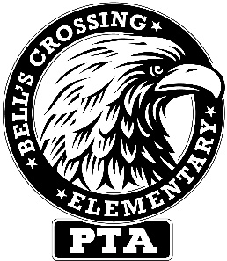

Bell’s Crossing Elementary PTA General Assembly Meeting Minutes
Monday March 11, 2019

A general assembly meeting of the Bell’s Crossing Elementary School (hereby known as BCES) Parent Teacher Association (hereby known as PTA) was held at Bell’s Crossing Elementary School in Simpsonville, SC on March 11, 2019. There were approximately 350 people in attendance. The meeting convened at 6:35pm with Lindsay Howell presiding.

Welcome – Mr. Ross welcomed everyone and turned the meeting over to Lindsay. Lindsay again welcomed everyone with special thanks to Mathnasium, teachers, staff, and our volunteers for helping make the Math Night event possible. The Great American Cookie Company in Five Forks was also recognized for the cookie donation for the event.
Upcoming Events – Staff Appreciation Luncheon on March 15. Spirit Night at Golden Skate on March 21 from 6-8pm. This event will also serve as an Iron Eagle Event. The Boosterthon Character and Fitness Program kicks off in April with the Fun Run on April 11. Boosterthon is our largest fundraiser of the year and this year the money raised will go towards an Extreme Library Makeover, a STEAM Lab, and other school improvements.
Presentation of the December 18 GA Meeting Minutes – The minutes from our GA Meeting on December 18 were presented and reviewed.
Present/Review Current Budget – Christine presented and reviewed our current budget.
Nominating Committee Report – Melinda Davidson presented the slate for the executive board members for the 2019-2020 school year. (listed below) The nominees will be voted in and inducted at our May 6 GA meeting.
President – Christine Way
President Elect – Stephanie Walsh
Secretary – Amber Lenger
Treasurer – Brandon Rich
VP Ways & Means – Shelbie Kurtz
VP Programs – Jessica Blanton
VP Volunteers – Jennifer Gsell
VP Communications – Wendi Robinson
Math Night Instructions – Dawn Sheriff from Mathnasium gave instructions on how math night operates.
The PTA portion of this meeting was adjourned at 6:55pm and was followed by Math Night, sponsored by Mathnasium.

BCES PTA Website : www.bellscrossingpta.org21tÿ

